Airline Safety from 1985 to 2014

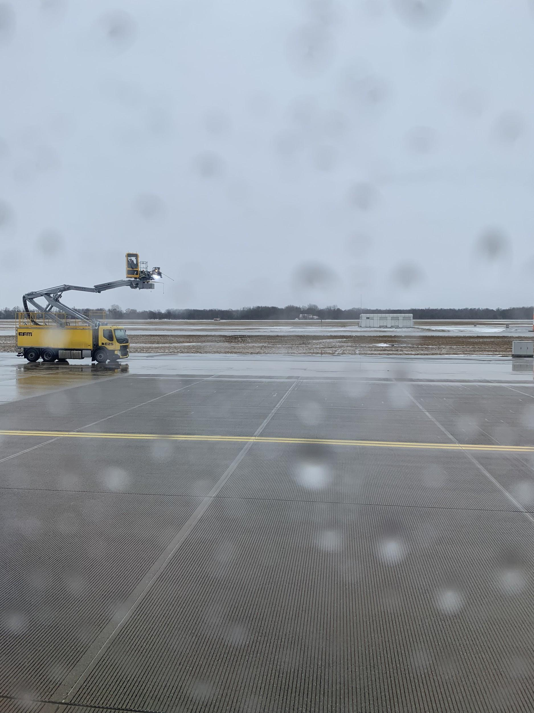

**Julio Corteza**

September 2020

Applied Data Science Capstone

# INTRODUCTION

As air travel rebounds from the effects of the Covid-19 or SARS-CoV-2 worldwide pandemic, airline safety in terms of past incidents (e.g. crashes, accidents, and disasters) which are either fatal or non-fatal are still important to explore. I will examine airline incident data from 1985-2014 from 56 airlines carriers worldwide. This report’s target audience will be the air traveler and perhaps will assist in the selection of which airline to choose. It is commonly known that higher profile airline disasters result in less demand to travel with that specific airline.

# PROBLEMS

What significant information can be gathered from past airline incidents?

Can a traveler who is concerned about safety make a decision about which airline to use from past airline safety data?